Kol aryeh:
Celebrating the second birthday of Aryeh Hirsch
With a Collection of Inspiring and Interesting Jewish Reading Materials
Compiled by Daniel Keren (the proud grandfather)
ARTICLES
Millions of Jews in…Afghanistan? An Interview with Nadav Sofy… A Blessing for Broadway… The Rambam’s Fame as A Doctor… The Chess Master Portraits That Escaped the Holocaust… Scouted by the Major Leagues, Nevada Teen Won’t Play on Shabbat… Larry King's Enormous Heart… Rabbi Chaim Aryeh Ginzberg Rediscovers the Beauty of Life… The Irreligious Shabbat Observing General… Amar’e Stoudemire, Now a Brooklyn Nets Coach, Doesn’t Work on Shabbat… How Much Do You Trust?... 19th Century Pair of Passover Plates… He is Israel’s ‘Prince of Torah.’ But to Some, He
Is the King of Covid

Millions of Jews in… Afghanistan? An Interview With Nadav Sofy
By Tzvi Fishman

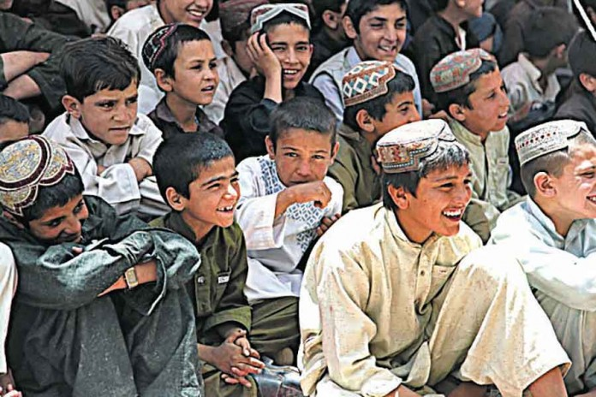Are they Jewish? Pashtun children. Photo Credit: Sgt. Joseph Jay Johnson

Although the Pashtun tribes in Afghanistan practice Islam, Nadav Sofy, head of the Association for the Bani Israel from Afghanistan, believes they are descended from the Children of Israel. The Jewish Press recently spoke to him to learn more about the subject and the goals of his organization.
The Jewish Press: Why do you think Pashtuns are really Jewish?

Sofy: Out of the 50 million Pashtuns who live in Afghanistan, Pakistan, and India, millions believe they are descendants of the 10 tribes of Israel, who were taken to Afghanistan thousands of years ago. One reason to support this claim is the many customs they have in common the Judaism such as lighting candles before Friday evening, washing their hands before eating from a special vessel called a koza, and not eating sea creatures such as lobsters, shrimps, and crabs.
They perform circumcision when a boy is an infant, not necessarily on the eighth day. Many of the men grow peyos and wear small head coverings and a square, four-cornered shawl called a shadaar. It is customary that a man marries his dead brother’s widow if the brother didn’t have children, similar to yibum. They observe many Jewish customs of mourning.

Pashtun Bride or Groom Breaks a Glass
Weddings are conducted under a chuppah known as a dolaye, and among the Pashtuns in Kandahar, the bride or groom breaks a glass. The star of David is a popular symbol in their art, tribal wear, and decoration. They also have names like Yaacov, Israel, Barak, Asaf, Benyamin, Kenan, Tamir, and Shir. The list of shared customs goes on and on.
Another striking sign is their facial features. They look like Jews, indicating they haven’t mixed with other peoples.
A lot of onsite research was conducted concerning the Beta Israel Jews from Ethiopia and the Bnei Menashe from India to verify that these people really are who they say they are. Have you been to Afghanistan to do such research?
No. That’s one of the difficulties in moving forward. Israelis are not allowed into the country, and even if you entered with a foreign passport and started doing investigative work about anything Jewish, it isn’t the friendliest place.
But I have met many Pashtuns in Israel, and their identification with our country and with Judaism is very emotional and real. Rav Baruch Efrati heads the hesder yeshiva Shvut Yisrael in Efrat. His grandfather, Rabbi Shimon Efrati, came from Afghanistan. He told me that his grandfather met the Pashtuns on many occasions and that everyone in their vicinity knew they were Jews who were exiled from Israel in the time of Ashur.

The Connection of the Pashums to the Lost Tribes
What other reasons do you have to believe that the Pashtuns can be traced back to the Lost Tribes?
Today, even in Afghanistan and Pakistan, many people have Internet. We have a page on Facebook, and we receive many comments from Afghans who trace their lineage back to Yaakov Avinu. They tell us about their customs which have their foundations in Judaism and their longing to form a closer connection to their “brothers and sisters” in Israel.
Not everyone in Afghanistan is a terrorist and an avowed enemy of the Zionists and Medinat Yisrael. A majority among the Taliban are from Pashtun tribes, and many believe they are Bnei Yisrael.
Under the influence of Islamic fundamentalism, others have become politically radicalized, and because of the atmosphere of terror, the identification with Israel is kept carefully hidden among the masses. But we have received a startling number of responses from Afghans and Pashtuns in Pakistan – thousands upon thousands – who welcome our efforts to reach out to them in friendship and who wish to share our common Israelite ancestry.
If not for the environment of fear surrounding their lives because of radical Islam, I am positive that we would be inundated with even more messages from people seeking an active bond with the people of Israel.
Another reason why the numbers are not even greater is the simple fact that not everyone in the mountains of Afghanistan has a computer or a smartphone.
Does their language resemble Hebrew?
No. But neither does the language of the Beta Israel from Ethiopia or the language of the Bnei Menashe Jews in India. Throughout history, Jews throughout the exile adopted the language of the countries where they lived or spoke variations of them like Ladino and Yiddish. The Pashtan language is called Pashto. It sounds like other Afghanistan dialects.
Is there any historical documentation to back up the connection of the Afghan tribes with the Lost Tribes?
Rabbi Binyamin of Todela wrote in the 12th century that there were some 80,000 Jews living in the mountains of Nesbor, located on Afghanistan’s border with Iran, along the river of Gozan. They wore traditional Jewish dress and followed Jewish traditions and considered themselves descendants of Dan, Zevulun, Asher, and Naftali, who had lived in the mountains of Nesbor since the exile of Shalmaneser, king of Assyria.
In the second Book of Kings (18:11) it states that the king of Assyria took tribes to Medes, located in Khorassan, a vast area that included Afghanistan. The History of the Afghans, written in the 17th century, records that lost tribes of Israel settled in the mountainous districts of Ghor, Ghazni, Kabul, and Kandahar.
Also in the 17th century, the Pashtun warrior-poet Khushal Khattak wrote that in “beauty, nobody can surpass Pashtuns because they actually belong to the family of prophet Yaakov.”
More recently, the founder of the Shaare Shamayim yeshiva for kabbalists in Jerusalem, Rabbi Shimon Zvi Horowitz, visited Afghanistan extensively. In his book, Kol Mevaser, he reports meeting with many Pashtun Jews and describes the customs and commandments they preserved dating back to the time following the destruction of the First Temple. Rav Kook wrote a recommendation and blessing for the book, praising his efforts to locate the Lost Tribes and emphasizing its importance for the redemption of the Jewish people.
Given the lack of absolute proof that the Pashtuns have not intermarried with gentiles, have there been discussions regarding the possibility of allowing them to convert like the Beta Israel and Bnei Menashe communities?
Due to the hostile attitudes toward Israel in Afghanistan and Pakistan, conversion is a sensitive and dangerous subject. At this time, it’s not feasible, so we don’t make it an issue. Rather, we promote a closer connection between Pashtuns and the people of Israel on the basis of brotherhood and a common heritage. This itself has great value.
[Seeking to clarify the matter, The Jewish Press investigated the question of conversion and discovered that the former Sephardi chief rabbi, Rav Shlomo Amar, addressed the subject in a letter to Ashkenazi Chief Rabbi David Lau, who agreed with Rabbi Amar’s conclusion. Rav Amar wrote that Pashtun groups have an unquestionable connection to Am Yisrael and harbor a desire for greater connection to full Jewish life, but must undergo a conversion resulting from doubt – similar to the conversion process of Beta Yisrael and Bnei Menashe.]
What about in the area of diplomatic relations between Israel and Afghanistan. Wouldn’t a treaty like the agreements Israel signed with the UAE and Morocco make your work easier?
No question about it. We hope our efforts will get things rolling in this direction, but serious complications stand in the way. Even though Afghanistan never went to war with Israel, the government is anti-Israel. This hostility has spread to the public who is constantly fed lies about Israel.
Pashtun communities have to maintain a low profile. So efforts to reach out, both on their part and ours, are fraught with difficulty. The Internet is the best tool we have, but like I mentioned, not everyone in the border zones of Afghanistan and Pakistan has access to the web.
Right now, we want to improve our presence on Facebook and greatly expand our membership, which stands at 50,000. We also would like to upgrade our halavi.org website. We also want to put out a song featuring Pashtun and Israeli singers together, and we’d like to initiate a Birthright-like visit Israel project. And we’re searching for an anthropologist who can thoroughly research the subject, which includes visiting the wide range of Pashtun communities. (January 15, 2021 – The Jewish Press)

Story #1206
A Blessing for Broadway
By Dudu Fisher
From the desk of Yerachmiel Tilles

I [Dudu Fisher] am descended from generations of those who opposed Chasidism, and yet I am walking this earth because of a blessing from a chasidic rebbe, Rabbi Yosef-Yitzchak Schneersohn the Rebbe Rayatz, who was the Rebbe of Chabad-Lubavitch from 1920 to 1950. This is what happened:

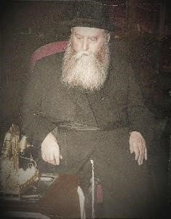
The Rebbe Rayatz

During the time that the Rebbe Rayatz was staying in Riga, Latvia, my grandparents were living on the outskirts of the city. In January of 1932, in the freeze of the winter, my grandmother went into labor with my mother, and things started to go wrong. She was rushed to the hospital where the doctors decided that it was necessary to abort the baby in order to save her life.
My grandmother, Frieda-Gisha, was unwilling to accept the doctor’s verdict but, fearing for her life, she asked her sister Leah to run to the nearest synagogue and pray for her. She said she would not make any decision until Leah returned.
So, in the middle of the night, Leah, my great-aunt, did just that like her sister asked, she ran to the nearest synagogue and started praying. She went up to the holy ark, where the Torah scrolls are kept, grabbed onto the curtain and pleaded with G-d for the life of her sister and her unborn baby.
As she was praying and crying, a woman tapped her on the shoulder. Leah did not know who this woman was perhaps the cleaning lady but when this woman said, “Come with me,” she followed her.
Together they went to where the Rebbe Rayatz was staying at the time and asked for his blessing. They received it in writing, and I still have it; it is a treasured possession in my family. It says: “With the help of G-d, everything will go well. You will give birth to a healthy and living child.”
Leah took this blessing and rushed to the hospital, where she was informed that her sister had just been taken into the delivery room. A short while later Frieda Gissa gave birth in a totally normal way to my mother, Miriam, whom the doctors had recommended aborting.

Our family has kept the Rebbe’s note for these many years. It is preserved in a safe, and we take it out only when a relative is giving birth so she can take it to the hospital with her. I myself have a copy, and I carry it with me wherever I go.
Two years after my grandmother gave birth to my mother, my grandparents left Latvia and went to live in Israel. It was just in time. The members of my family who stayed behind - fourteen in total - were murdered by the Latvians in the streets. We have witness testimony from those who saw it happen.
Meanwhile, my mother grew up in Israel with an unusual attachment to Chabad, despite her father’s anti-chasidic attitudes. Later on, it was in her house, and with her help, that Rabbi Menashe Althaus started the Chabad Center in Tivon.
Myself, I enlisted in the IDF, and after I completed my army service, I started singing professionally. I was a cantor for many years. Then, while I was in London for a cantorial concert, a cousin invited me to see the musical, Les Miserables, and when I went back to Israel, I told my manager that I wanted to take part in the Hebrew production.
He had no idea what I was talking about, but he quickly found out that “Les Miserables” called in Hebrew, “Aluvay HaChaim” was coming to a theater in Tel Aviv. I got the part and became famous for it.
While I was performing in Tel Aviv, Sir Cameron Mackintosh, the world producer of “Les Miserables,” saw my performance and asked me to come to Broadway. I was stunned.

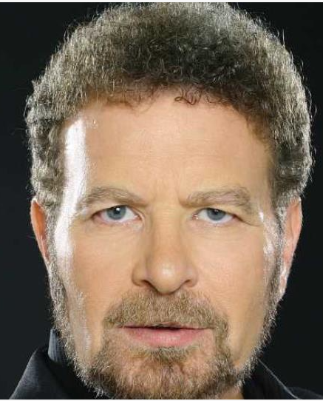
Dudu Fisher

Of course, every singer wants to appear on Broadway, but I turned him down. I said, “I don’t think this will be possible for me, because I am an observant Jew; I don’t work on Shabbat or on Jewish holidays.”
He said, “Let us meet again to see how we can solve this problem.”

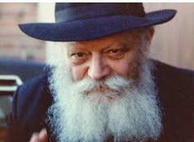
The Lubavitcher Rebbe, zt”l

Meanwhile, the story leaked out to the media and the Israeli newspapers blared, “Dudu Fisher goes to Broadway,” which was by no means a done-deal.
My mother saw that this whole thing was making me depressed, and she suggested, “Why don’t you go see the Lubavitcher Rebbe in Brooklyn, the successor to the one who blessed your grandmother?”
I said, “What am I going to talk to him about Broadway? So many people are coming to him with real troubles like poverty and illness. How can I bother him with this?” She insisted, “The blessing of a Lubavitcher Rebbe helped us once before; it will help us again.”
This was in early 1992. It was no longer possible to see him in a private audience, but it was possible to receive a dollar for charity and a blessing every Sunday.
When my turn came the Rebbe gave me a blessing and told me not to worry; everything would turn out well. His exact words were, “G-d willing, you will hear good news soon. You will go from strength to strength.”
And that is exactly what happened.

I got the part. Not only that, the Playbill featured the announcement that, for religious reasons, Dudu Fisher would not be playing the part of Jean Valjean on Friday nights and during Saturday matinees.
In fact, this outcome was nothing short of a miracle -- which never happened before or after, it was a one-time only occurrence.
They called me “the Sandy Koufax of the theater” referring to the great Jewish baseball player who refused to participate in the 1965 World Series because it fell on Yom Kippur.
Personally, I consider it one of the biggest achievements of my life. When I leave this earth, I hope that people will remember me for this: that I would not violate Shabbat and that I showed it was possible to make it in the world without compromising one’s beliefs.
But, most of all, I am ever so grateful to the Rebbe for helping me to get this message across to the Jewish world at large.
~~~~~~~~~~~~~~~~~~~~~~
Source: Edited and supplemented by Yerachmiel Tilles from a mailing of "JEM - Here's My Story (//JEmedia.org), as part of their extraordinary My Encounter with the Rebbe project, documenting the life of the Lubavitcher Rebbe, Rabbi M. M. Schneerson of righteous memory. More than 1500 videotaped interviews have been conducted to date, all based on the recollections of the people recounting them.
Dudu Fisher is a famed Israeli cantor and popular singer, who also played the role of Jean Valjean in the musical Les Miserables in Tel Aviv, in New York and in London. He was interviewed in July of 2015, a few months before his 64th birthday.

Reprinted from the Parshat Bo 5781 email of KabbalaOnline.org, a project of Ascent of Safed.

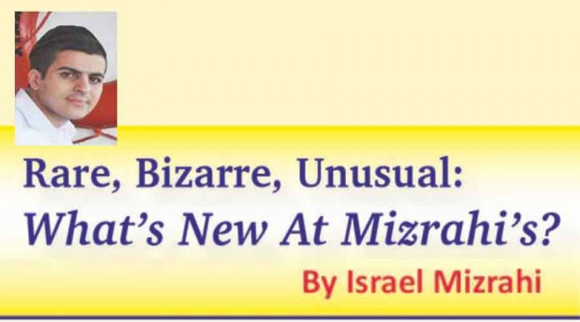
The Rambam’s Fame
As A Doctor

While the Rambam is remembered today for his great rabbinic writings, for centuries his most-often printed works were his medical writings. This week I acquired Pirke Moshe, printed in Vilna in 1888, which is a collection of the Rambam’s remedies for various ailments.
Born in Cordoba, Spain in 1138, the Rambam and his family were forced to escape the region when he was 13 after it was captured by the Almohades, a fanatical Berber Muslim group. After wandering for many years – living in Fez, Morocco and for a brief period in Eretz Yisrael – he settled in Egypt in 1168.
After the death of his brother David en route to India for business, and consequent financial difficulties for the family, the Rambam was forced to take upon himself the occupation of physician. Gaining widespread recognition, he was appointed court physician to the Grand Vizier al-Qadi al Fadil, then to Sultan Saladin, after whose death he remained a physician to the Ayyubid dynasty in Egypt.
The Rambam wrote his medical works in Arabic, and they emphasize moderation and living a healthy lifestyle. They describe many ailments such as asthma, diabetes, hepatitis, and pneumonia, and the Rambam was one of the first physicians to write about treating depression. In a medical letter to the nephew of Saladin the Great in Cairo, the Rambam discusses possible remedies for depression, including alcohol.

Ten known works of the Rambam on medical topics exist, and they have all been translated into many languages, including English. A traditional prayer used by many doctors and pharmacists to this day is attributed to the Rambam and attests to his devotion to his patients. The prayer begins:

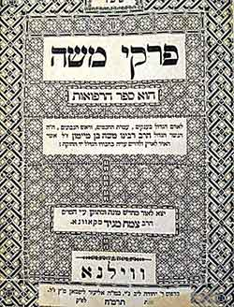

“The Eternal Providence has appointed me to watch over the life and health of Thy creatures. May the love for my art motivate me at all times; may neither greed nor miserliness, nor thirst for glory or a great reputation engage my mind; for the enemies of truth and philanthropy could easily deceive me and make me forgetful of my lofty aim of doing good to Thy children.”
The influence of the Rambam on the medical field can be seen by the numerous editions of his works that were published in many languages throughout the centuries. Indeed, his fame as a healer was so great that in Egypt, as late as the 20th century, it was a custom in the Jewish community to carry ill patients to the old synagogue of Maimonides and leave them to sleep under the main prayer room.
When King Faud I of Egypt was seriously ill in 1935, the loyal inhabitants of the Jewish quarter borrowed some of the ruler’s clothing and took them to the prayer room where they kept them for a week. They were convinced that the subsequent improvement in the king’s condition was due to the blessing of the Rambam. (January 15, 2021 – The Jewish Press)

Remembering Sheldon Adelson
By Rabbi Shraga Simmons

The casino tycoon set new standards of Jewish mega-giving.

The Jewish world has lost one of its most prolific funders with the passing of Sheldon Adelson, whose business empire spanned continents and whose $35 billion personal fortune ranked him #38 on the Forbes list worldwide.
At times outspoken and controversial, Adelson, age 87, had been receiving treatment for non-Hodgkin’s lymphoma.
Philanthropy
Though Jews are disproportionately generous in charitable giving, less than 10 percent of Jewish mega-donations go to Jewish or Israeli causes.

The Adelson Broke the Mold in Charity Giving
Sheldon Adelson broke that mold. Together with his wife Miriam, the Adelson Family Charitable Trust donates $200 million annually to Jewish and Israeli causes, including:
$400 million total to Birthright, which has sent 600,000 young Jews with free trips to Israel
$25 million to Yad Vashem, Israel’s Holocaust museum
$50 million to Adelson Educational Campus, the largest Jewish school in Las Vegas
$20 million to open a new medical school at Israel’s Ariel University
The Adelson School of Entrepreneurship at IDC Herzliya college
Adelson credited this ethos to his father, who “kept a charity box for the poor in our house.” Charitable giving, he said, “is my humanitarian legacy. We’re prepared to pay billions.”

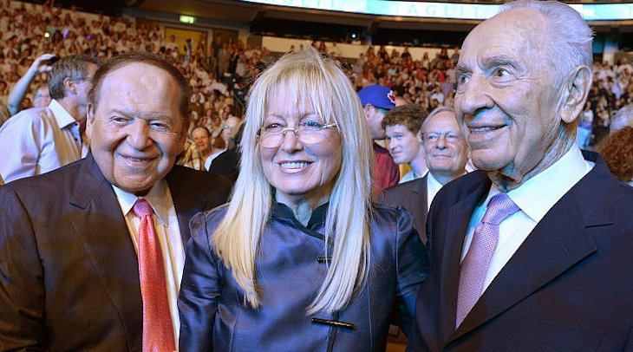Sheldon and Miriam Adelson at a Birthright event with former Israeli President Shimon Peres. (credit: GPO)

Largest Individual Political Donor in America
Another hefty chunk of Adelson’s donations went to U.S. political campaigns. An estimated $340 million went to Republican candidates in the past few years, making him the largest individual donor in the country.
Adelson also influenced the political milieu through his ownership of media outlets, including the Las Vegas Review-Journal, the largest circulation daily in Nevada and one of America’s top-25 newspapers. In Israel, after an unsuccessful attempt to purchase an existing newspaper, Adelson started his own, Israel Hayom, which is now the country’s largest-circulation daily.
Adelson was unabashedly pro-Israel, and was hawkish about issues relating to Jerusalem, the Palestinians, and Iran. In 2013, Adelson suggested sending a nuclear missile to the Iranian desert – “that doesn't hurt a soul, maybe a couple of rattlesnakes and scorpions” – as a message to the Ayatollah’s radical regime to abandon its nuclear weapons program.
Sheldon Adelson was born in 1933 in Boston to a low-income Jewish family. His father, of Ukrainian and Lithuanian ancestry, drove a taxi. His mother, an immigrant from England (whose father was a Welsh coal miner), ran a knitting shop.
Adelson took to entrepreneurship early in life and at age 12 borrowed $200 from his uncle for a license to sell newspapers. At age 16, he borrowed $10,000 from his uncle to start a candy-vending-machine business.
Through his first marriage, Adelson adopted three children. His son Mitchell died of a drug overdose, leading Adelson to crusade against legalized marijuana, considering it a “gateway drug” to the cocaine and heroin that claimed his son’s life.
In 1991, Adelson met his second wife, Miriam, on a blind date. A child of Polish refugees, she grew up in Israel and achieved success as chief internist in the emergency room of Tel Aviv's Rokach Hospital. She shared her husband’s opposition to drugs and founded a substance abuse clinic.

Serial Entrepreneur
Adelson’s business breakthrough came in 1979 when he created COMDEX, the computer trade show in Las Vegas. The timing was fortuitous, as the personal computer industry – IBM, Apple, Microsoft – was just taking off and COMDEX quickly became the largest trade show in Las Vegas. Adelson later sold it for a personal profit of $500 million.
In 1988, Adelson and his partners purchased the legendary Sands Casino in Las Vegas, marking the start of a deep foray into resort development. In 1991, while on honeymoon with Miriam in Venice, Italy, Adelson got an idea which later materialized as the $1.5 billion, 4,000-room Venetian casino in Las Vegas – complete with canals, gondolas and singing gondoliers.
Adelson later built China's first Las Vegas-style casino on the island of Macau, the center of a massive Asian gambling market – featuring a half-scale copy of the Eiffel Tower. Adelson’s vision continued to expand and in 2010 he opened the Marina Bay Sands in Singapore at a cost of $5.5 billion – the third-most expensive building in the world.

The spectacular Marina Bay Sands in Singapore is known as the “most-Instagrammed hotel in the world.”

In 2014, Adelson was named to CNBC's list of transformational business "leaders, icons and rebels… who have had the greatest influence, sparked the biggest changes, and caused the most disruption in business over the past quarter century."
Adelson explained his philosophy of entrepreneurship: “Businesses are like buses. You stand on a corner and you don’t like where the first bus is going? Wait ten minutes and take another. Don’t like that one? They’ll just keep coming. There’s no end to buses or businesses.”
Once, when his business holdings suffered a 93 percent drop in value, Adelson said: "So I lost $25 billion. I started out with zero... [There is] no such thing as fear, not to an entrepreneur.” He described an entrepreneur as possessing “courage, faith in yourself, and above all, even when you fail, to learn from failure and get up and try again.” (Within two years, Adelson’s business had recovered.)
Despite great financial success, Adelson claimed not to be motivated by money. “I never thought about becoming wealthy,” he said. “It never crossed my mind. What really motivated me was to try to accomplish something.”
Adelson’s gift of $70 million to Birthright – in honor of Israel’s 70th anniversary – solidified his leading position in Jewish philanthropy. “Before Israel was founded, my father always said he wished there was a place where Jewish people

The Chess Master Portraits That Escaped the Holocaust
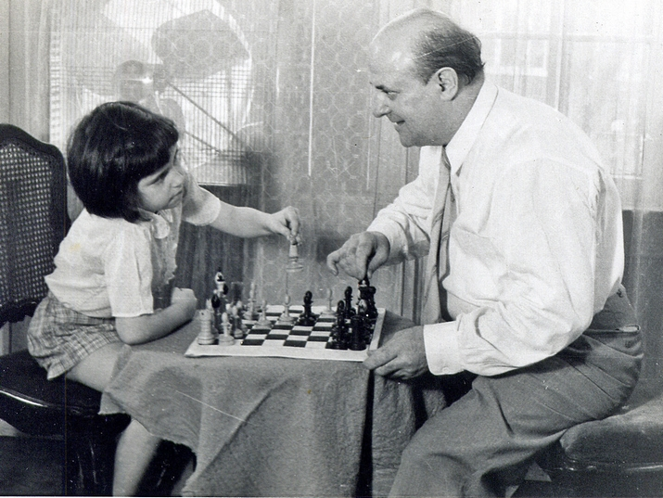
Miriam Friedman Morris with her father, the chess enthusiast and portraitist, David Friedmann. St. Louis, 1957

The Netflix miniseries “Queen’s Gambit” inspired recollections of world-famous chess master portraits created roughly a century ago by my father, David Friedmann. It was exciting to hear some of the names he portrayed, including Capablanca, Bogoljubov, Grunfeld, Alekhine, and Réti.

Chess, Art, Celebrity

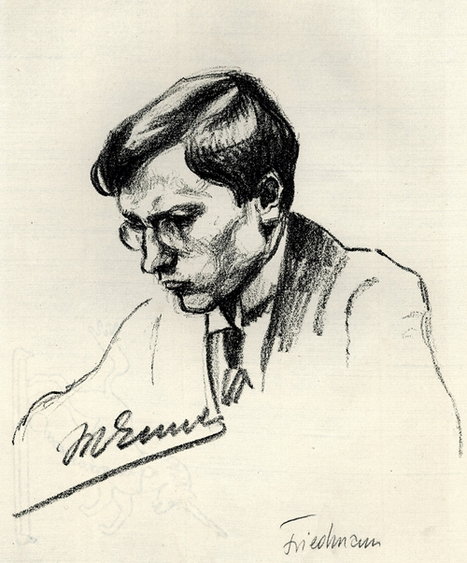
Lithograph portrait of Max Euwe by David Friedmann, 1923. From the National Library of the Netherlands

My father was a violinist and chess enthusiast. As a professional artist, he had the opportunity to befriend notables in sports and culture.
Among these celebrated personalities, he captured the great chess champions of the 1920’s. I can visualize my father at tournaments, standing among other spectators with pencil and sketchbook in-hand.
His portraits convey an intimacy of one who understands the game. Drawings show players in deep concentration, looking down at their chessboard and pieces. One feels the drama of the tournament in the quiet atmosphere of a smoke-filled room.
My father was born in Mährisch Ostrau in 1893, then Austria-Hungary, today Ostrava in the Czech Republic. At the age of seventeen, he ventured to Berlin and studied etching with Hermann Struck and painting with Lovis Corinth. He became a successful painter and graphics artist renowned for portraits drawn from life.
He planned to attend an international chess tournament in Ostrava from July 1 to July 18, 1923. In Berlin, he met with chess legend Dr. Emanuel Lasker, who, until 1921, had reigned as world chess champion for nearly three decades. As my father explained his intent to issue a portfolio of the players’ portraits, Lasker enthusiastically endorsed the idea and later wrote the portfolio’s foreword.
By the end of 1923, my father’s art was propelled in a new direction due to the widespread recognition of his sensational portraits. He was sought after, and became a leading press artist in Berlin.
However, when Hitler came to power in 1933, my father’s flourishing career abruptly ended.
His talent for quick-sketching and portraiture played a central role throughout his career and saved his life during the Holocaust. In 1941, Nazi authorities looted his left-behind art in Berlin and Prague.
His wife Mathilde and young daughter Mirjam Helene were murdered in Auschwitz.

Wandering and Rebuilding
Torn from his memories, after liberation he created the powerful series, “Because They Were Jews!” The artwork shows the scenes he witnessed, from deportation to the Lodz Ghetto, Auschwitz, and further to other concentration camps until his liberation.
In Prague, in 1948, my father wed Hildegard Taussig, also a survivor. Their marriage began at a refugee’s pace as they fled Stalinist Czechoslovakia to Israel a year later. In 1954, the couple immigrated to the United States with me, their daughter, also named Miriam. The family became American citizens in 1960 and dropped the double “n” spelling of their surname.
The walls of our St. Louis home were covered with postwar art produced during my father’s journey from Czechoslovakia to Israel and the United States.
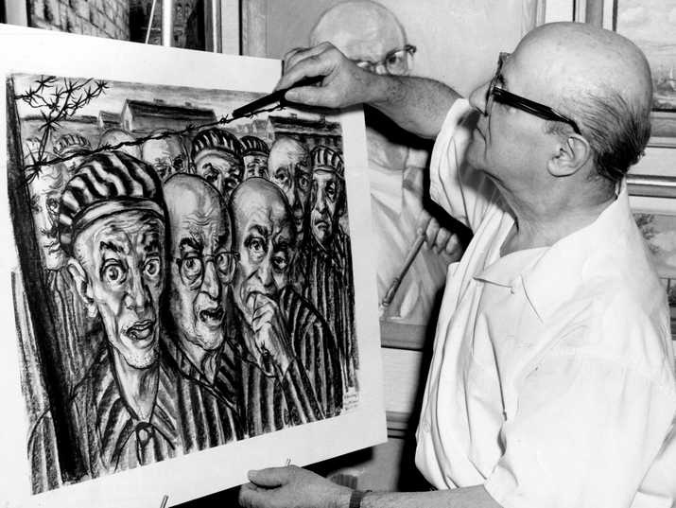
David Friedmann adds final touches to his charcoal drawing, “Liberation?” St. Louis, USA, 1964 (Photo: Peter Rosvik)

He had little to show from a collection of hundreds of paintings, drawings, etchings, and lithographs.
In June 1973, a search by my father turned up a portfolio at the Ostrava Museum. My father radiated with excitement when professional photos of his portfolio arrived.
“You see Miri, I was really a famous artist before the war. I was known for these portraits.”
A significant piece of his legacy had escaped Nazi destruction. Thus, I was introduced to Emanuel Lasker, Richard Réti, Ernst Grünfeld, Alexey Selesnieff, Machgielis (Max) Euwe, Savielly Tartakower, Efim Bogoljubow, Siegbert Tarrasch, Rudolf Spielmann, Akiba Rubinstein, Amos Pokorny, Karel Hromádka, Heinrich Wolf, and Max Walter.

A Vanished Portfolio
At the time, I was unaware the portfolio would be a catalyst for unfolding layers of David Friedmann’s history. I knew my father as a prolific artist with many talents, but it would take decades after his death in 1980, to piece together his extraordinary life and contributions to the art world.
I came to Ostrava in 1994. The city was as my father recalled. The air in this mining and metallurgical center still hinted of the smoke and smells of coal and sulfur. The chimneys and mining towers documented by my father were testimony to the city’s industrial past. Two works showing this side of Ostrava surfaced in the Visual Arts Collection of the Jewish Museum in Prague.

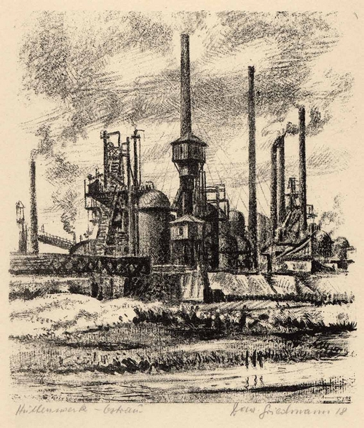
“Hüttenwerk Ostrau” (Iron works in Ostrava) lithograph on paper by David Friedmann, 1918. From the Visual Arts Collection of the Jewish Museum in Prague (Id# 79.680); Provenance: received through the Treuhandstelle Prag in 1944

At the Ostrava Museum, no record existed of the titled portfolio, Das Schachmeister Turnier in Mährisch Ostrau (The Chess Master Tournament).
The portfolio my father had been thrilled to find had simply vanished.
I placed advertisements in newspapers, but received no response for any David Friedmann artwork. I continued my pursuit in Berlin.

Jewish Chess Masters

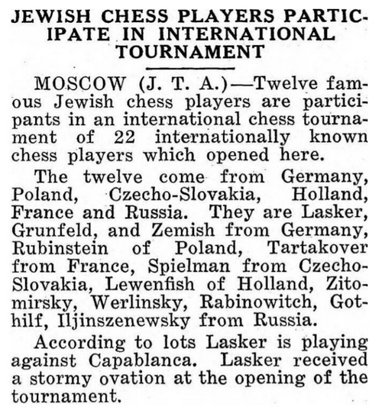
Published in The Sentinel, 20 November 1925. From the National Library of Israel Digital Collection

In the 1920’s, chess masters were the superstars of their time. An important newspaper without at least a page of daily chess news was inconceivable. It was gratifying to find Friedmann portraits in Berlin’s newspapers.
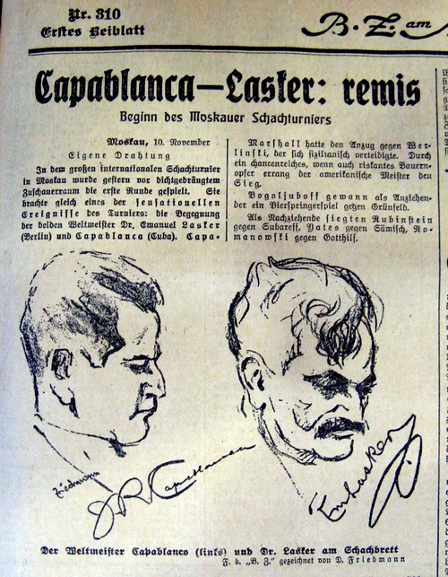
Emanuel Lasker versus Jose Raul Capablanca. Published in B.Z. am Mittag, 11 November 1925

The drawings were produced simultaneously with current events. I felt especially victorious each time a chess player appeared on the page. It became apparent my father attended chess matches – often. Editors throughout Germany and German-speaking countries, published the portraits repeatedly for years to come.
Anticipation was in the air as fragile pages were cautiously turned, hoping something new would emerge.
The majority of articles featured Bogoljubow, Capablanca, and the Jewish players Lasker, Tartakower, Nimzowitsch, and Spielmann.
In 1933, all professional careers of Jews in Germany ceased to exist. Alekhine and Bogoljubow played in Nazi-sponsored events.
Players of Jewish origin were not eligible for chess club membership in Germany or to participate in national tournaments. Despite worldwide fame, they shared the fate of millions of their fellow Jews – they suffered Nazi persecution, loss of home and country, and annihilation. As I would discover, German Jewish refugees fleeing the Nazis brought my father’s portfolios and artwork to England and other countries around the world.
Rediscovering the Portfolios
At the newspaper archive in Berlin, the first drawings I came across were mainly published in the B.Z. am Mittag and 8 Uhr-Abendblatt. During subsequent research trips, an abundance of portraits turned up in numerous newspapers.
Most were signed by the subject and by the artist in various signatures and unknown versions: DaFrie, D.Fr, Fried, and Fr.Dav.
I had not paid much attention to artwork signatures at home. Now I saw that my father enjoyed changing his signature from the time of his early career until he could no longer paint.

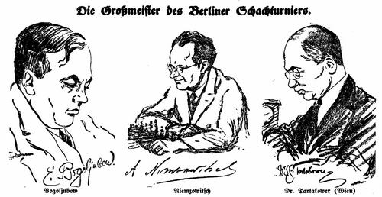
“The Grandmasters of the Berlin Chess Tournaments,” from left to right:
Efim Bogoljubow, Aron Nimzowitsch, Savielly Tartakower. Published in
Gross-Berliner Ost-Zeitung, 2 September 1928

The September 1996 issue of the U.S. Chess Federation magazine, Chess Life, featured my article, “David Friedmann’s Artwork for Berlin’s Newspapers,” which tells the story of my father’s interwar career and my search for his lost and looted art.
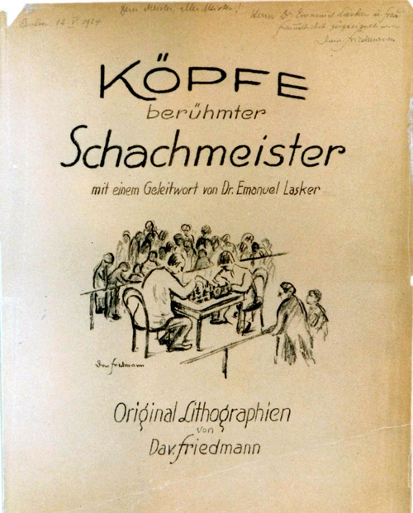
Title page of Köpfe berühmter Schachmeister (Portraits of Famous Chess Masters) © 1999 Miriam Friedman Morris. From a private collection

The editor chose to publish the portfolio portraits instead of those found in the newspapers. This brought about astounding results in terms of my search. I received news from a collector owning a portfolio titled Köpfe berühmter Schachmeister (Portraits of Famous Chess Masters).
An extraordinary find, because it had belonged to Emanuel Lasker. The title page carried a personal inscription handwritten to Lasker and signed by Dav. Friedmann, dated May 12, 1924, Berlin.
The Nazis drove Lasker out of Germany. He fled first to England, then from the U.S.S.R to the United States, all the while somehow managing to save my father’s portfolio. The portfolio consisted of only 12 portraits, and was numbered 27/50. This presumes there had been 50 portfolios with this title. Here was evidence that my father produced sets different from the original.

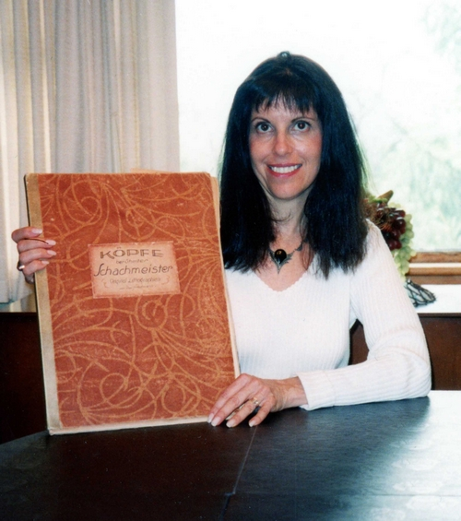
Miriam Friedman Morris in 1996 with Portfolio No. 27 of Köpfe berühmter Schachmeister, once owned by Emanuel Lasker

While my father searched for his art in Europe, this collector was in California, where he had purchased part of Lasker’s estate. Twenty-three years later, at the collector’s home, I joyously held Lasker’s portfolio, a celebratory event I wished I could have shared with my father.

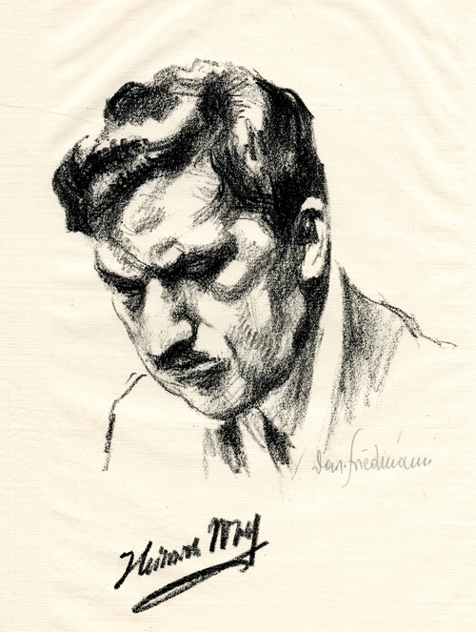
Lithograph portrait of Heinrich Wolf by David Friedmann, 1923. Wolf did not escape Europe and was murdered in the Riga Ghetto in 1941. From the Special Collections of the Cleveland Public Library

Finally, I saw an original portrait portfolio.
All of the lithograph prints bear the depicted player’s signature, which, along with the portrait, were part of the original plate. A signature variation of Dav. Friedmann was handwritten in pencil on each print.

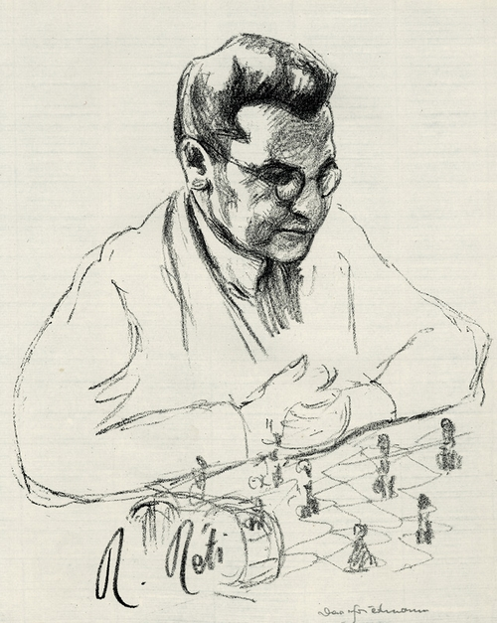
Lithograph portrait of Richard Réti by David Friedmann, 1923. Réti is remembered as a legendary player and author of books about chess; he died of scarlet fever in 1929. From the National Library of the Netherlands

Additional portfolios with this title were found with 12 or 14 portraits. Portfolio No. 23 was purchased by a collector from a London dealer. Dutch collector Dr. Meindert Niemeijer donated Portfolio No. 28, which includes Ossip Bernstein and Richard Teichmann, to the National Library of the Netherlands, where it is now part of the second largest public chess collection in the world and can be viewed in its entirety online.
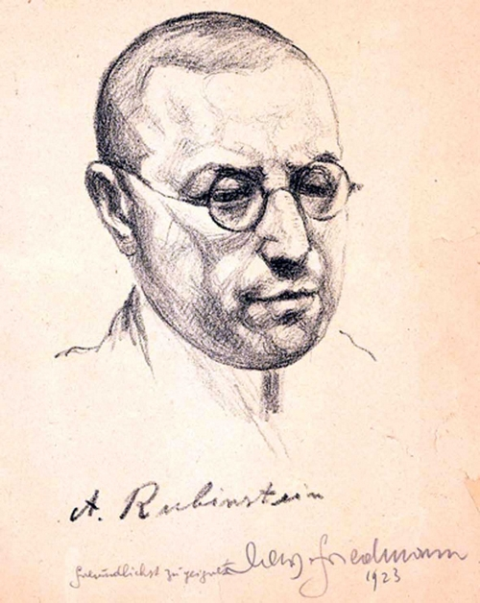
Lithograph portrait of Akiba Rubinstein by David Friedmann, 1923. During the Nazi occupation, Rubinstein hid in a Belgian sanitarium. From the collection of the Jewish Museum in Brussels

Questions and Answers
I speculate that my father’s first sets were limited to those interested in the Ostrava tournament, a good reason to continue his numbered sets with the new broader title.

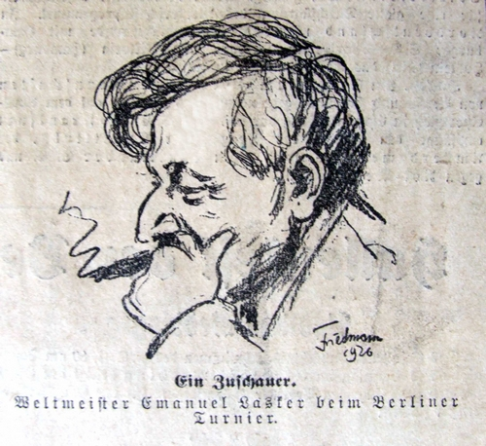
Emanuel Lasker at the Berlin International Tournament. Printed in
8 Uhr-Abendblatt, 20 November 1926

This also gave the opportunity to customize a portfolio according to a buyer’s preference. Perhaps, besides Lasker, there were portfolios in the estates of other noted players. Rubinstein’s portrait, also with a handwritten dedication, turned up at the Jewish Museum in Brussels.
Both had been sent to the masters in August 1923. I wonder if my father sent first prints to all the players in the tournament.

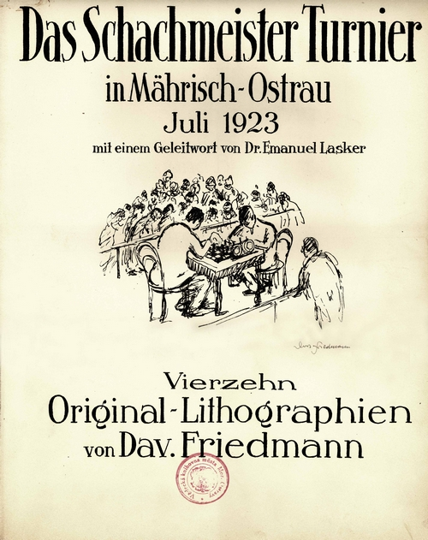
Title page of Köpfe berühmter Schachmeister (Portraits of Famous Chess Masters) © 1999 Miriam Friedman Morris. From the Ostrava Museum Collection Kábrtová was emotional to find the long sought-after treasure.

The Chess Life article prompted author Felix Berkovitch to convey a most intriguing observation in a letter dated September 24, 1999:
“Enclosed are several pages from Vladimir Nabokov’s novel, The Defense (G. P. Putnam’s Sons, NY, 1964). I was stunned to read about an artist who had been sent by his newspaper to the Berlin International Chess Tournament to sketch the participants (page 125). It is a novel, but we can recognize a number of the real people. For instance, the German Grandmaster with an extinguished cigar is Emanuel Lasker. Turati, as he is described on page 96, is Richard Réti. You may certainly guess who is the artist!”

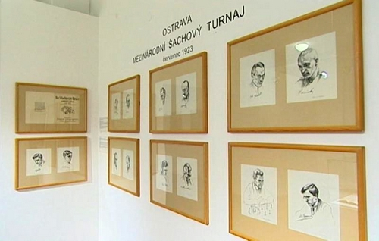
David Friedmann’s famous portraits on display at the Ostrava Museum in 2013, eighty years after his first exhibition at Gallery Slatner. The exhibition featured July 1923’s Portfolio No. 4 of Das Schachmeister Turnier in Mährisch Ostrau, the only known portfolio with this title. Screenshot: Česká televise

Back in Ostrava
Then, in 2006, an incredible stroke of fortune.
I received news from Jiřina Kábrtová, the director of the Ostrava Museum, that she had found the lost Portfolio No. 4/50 of Das Schachmeister Turnier.
During the library’s move to the old city hall building, the portfolio surprisingly appeared at the bottom of a book stack!

How had the portfolio been lost? It had apparently not been registered as art, but rather as a book in the museum’s library collection. No one thought to look for it there.
In 2013, the museum held an exhibition about the fate of Ostrava’s Jews: “Nezapomněli jsme na ně? Stopy židovských rodin v Ostravě” (Have We Not Forgotten Them? Traces of Jewish Families in Ostrava). David Friedmann was a featured biography.

The original chess player portraits were displayed along with digital prints of his renowned musician sketches printed in Berlin publications. In his diary, my father remarked upon his return to Ostrava in 1945 that he was an unknown.
Now, he was honored with an exhibition in his birthplace.
One feels the gap in the artist’s life – the absence of artwork depicting family and the multitude of landscapes and still lifes he would have produced in various media.
Later the same year, Portfolio No. 26 of Köpfe berühmter Schachmeister, with 14 portraits, surfaced in the estate of New York chess player and collector Fred Snitzer.
Apparently, he had acquired the portfolio from a London art dealer in 1967. The Snitzer heirs contacted me, truly a heartwarming understanding of my quest.
Upon my recommendation, the portfolio was donated to the John G. White Chess and Checkers Collections, Fine Arts & Special Collections of the Cleveland Public Library, the largest chess collection in the world. It is now available online.
American International Master of Chess John Donaldson wrote to me, “You are doing great work making your father’s art available to all to appreciate.”
It is important to have my father’s works in public collections where people can view them and learn his story. That is my goal.

Chess and Life
It is a victory that six portfolios were rescued from the devastation of World War II. The sixth find is in a private collection and holds only 10 portraits. Every portfolio has a story, but the details of their survival are mostly lost. I recall my father’s passion for art, his enjoyment in playing chess, and even to teaching me to play.
Chances are slim that original portraits will still surface. It is likely that German Grandmaster Lothar Schmid, one of the world’s leading collectors, would have found a portfolio if there was one to find. He remarked in a 1996 letter, “let us try more or less together to find more about your father’s steps.”
At Berlin’s 1925 Juryfreie Kunstschau (Jury-free Art Show), four David Friedmann works were displayed, including the watercolor, Die Schachspieler (The Chess Players).
This painting has a title, one of few found in exhibition and auction catalogs of the 1920’s and early 1930’s. Die Schachspieler represents hundreds of his lost works – testimony to Nazi-looted art and the destruction of European civilization.
The Nazis nearly erased my father from history, but they did not succeed. His life was a chronicle of resilience, courage and achievement.
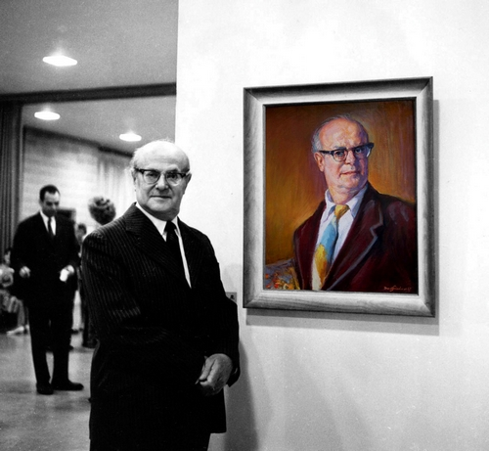
David Friedmann posing with a self-portrait. St. Louis, USA, 1967

David Friedmann’s artwork has received international acclaim and his chess player portraits are recognized as iconic collectibles.
My father’s artwork launched a journey of discovery into his past, and a unique first-hand look into the fascinating world of chess.
—
This article has been published as part of Gesher L’Europa, the National Library of Israel’s initiative to share stories and connect with people, institutions and communities in Europe and beyond.
For more about David Friedmann and to provide information you may have about existing works, please visit: www.davidfriedmann.org or the “David Friedmann—Artist As Witness” Facebook page.
All images from Das Schachmeister Tournier in Mährisch Ostrau, Juli 1923 and Köpfe berühmter Schachmeister © 1999 Miriam Friedman Morris. All Rights Reserved.

Reprinted from January 14, 2021 email of the National Library of Israel.
Scouted by the Major Leagues, Nevada Teen Won’t Play on Shabbat
By Faygie Levy Holt

Elie Kligman, a high school senior from Las Vegas who is one of the top-ranked players in Nevada and has been scouted by the Major Leagues, has never played on Shabbat, makes time to pray three times a day and keeps the Jewish dietary laws of kashrut.
For decades, Jewish baseball fans have looked to Sandy Koufax as a role model for refusing to pitch in game one of the 1965 World Series because it fell on Yom Kippur. While that stood out as an example for Jews everywhere, one Nevada teen is hoping to take it a step further and become the first Shabbat-observant, kosher-food-eating professional baseball player.
“My dream has always been to be a Major Leaguer. I never thought of anything else—baseball has always been what I’ve wanted to do,” says Elie Kligman, a high school senior from Las Vegas who plays as both an infielder and pitcher.

Has Been Playing Ball His Entire Life
The 18-year-old has been playing ball his entire life. After years of competing at all levels, Elie, who is on his high school team and one of the top-ranked players in Nevada, was one of only 175 high-schoolers from across the country—and the first Orthodox Jew—to take part in the Major League Baseball-scouted “Area Code Baseball Games.”
He does all this without compromising his Judaism. Elie has never played on Shabbat, makes time to pray three times a day and keeps the Jewish dietary laws of kashrut.
“I have the mindset of, ‘This is what I am doing for Judaism, and this is what I am doing for baseball.’ Once the sun goes down on Friday night, it’s not a debate for me, [celebrating Shabbat] is just what I am doing,” says the teen. “When you are a proud Jew, people respect when I tell them I’m not going to play on Friday night and Saturday.”

People are Interested in What He Eats and Does on Shabbat
In fact, he adds, people are actually interested in what he eats and what he does on Shabbat.
Elie was one of only 175 high-schoolers from across the country—and the first Orthodox Jew—to take part in the Major League Baseball-scouted “Area Code Baseball Games.”
Guiding him in his life and career has been his father, Marc Kligman, an attorney and professional sports agent who has coached Elie and younger brother Ari in the finer points of baseball over the years. He has also worked hard to provide his boys with opportunities to compete at a high level.
“We’ve had a lot of help along the way,” he says. “People have been kind and helpful. Our head coach at the high school makes sure we don’t schedule any games on Saturday.”
But there have been plenty of times that the Kligman boys have had to sprint out of the house right after Shabbat ended to make a Saturday-night game, as well as “plenty of Shabbats alone in a hotel so we could be local” for a game, say their dad.
The Kligmans, including mom Laura and Elie’s twin sister, Tova, are members of Chabad of Summerlin, a suburb of Las Vegas. Their involvement with Chabad has made things easier over the years, as wherever they find themselves traveling to for a ball game, they make sure to visit the local Chabad House, where they can find kosher food or catch a prayer service.
“It’s a taste of home,” says Kligman. While Elie notes that other Chabad Houses have all been “awesome, especially the Chabad of Phoenix, we know a lot of the community because we go there a lot” for tournaments.

Wherever Elie and his family travel for a ball game, they make sure to visit the local Chabad House, where they can find kosher food or catch a prayer service.

‘His Yiddishkeit Takes Precedence’
According to Rabbi Shea Harlig, director of Chabad of Southern Nevada, “It’s wonderful to watch Elie balance his commitment to a Torah-observant lifestyle and baseball at the same time, but when there is a conflict, his Yiddishkeit takes precedence.”
In fact, Elie and Ari both make time to study Torah, learning with Rabbi Chaim Ozer Metal, the youth director at Chabad of Summerlin, who says the family’s love of Judaism has even impacted others.
“Because of Elie and his family’s strong sense of Judaism, even when being out there playing baseball, they once encouraged a family to meet with me, which together resulted in the family putting mezuzot on their doors and enrolling their children in Hebrew school,” relates the rabbi.

For now, Elie is waiting to hear where he’ll be going to college, and if he will break new ground as the first Orthodox Jewish baseball player at a Division 1 school. (There have been several Orthodox teens who have played Division 1 basketball, starting with Maryland native Tamir Goodman in 2000.) If Elie does get recruited to a Division 1 school, then he’ll be among some of the country’s best college baseball players, moving him one step closer to his dream of playing in the Major Leagues.
One thing that won’t change, though, is his Judaism.
“People always ask me what I’m going to do in college,” says Elie. “The answer has always been I’m not playing on Shabbat. It’s for G-d, and I’m not changing that.”

Reprinted from the January 14, 2021 dispatch of Chabad.Org News.

Larry King's
Enormous Heart
By Rabbi Irwin Katsof

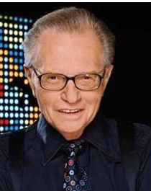
Behind the glitz of Hollywood, Larry was a kind, caring soul who recognized his Jewish roots and used his fame to help the Jewish people.

I met Larry King in 1995. Together with my production colleague Lou Rudolph, Aish Hatorah was attempting to launch an international satellite broadcast to bring awareness to the Jewish community about the plight of Soviet Jews. It was called “Help our People Know” and it was failing dismally.

A Chance to Meet Larry King
Then a friend of Lou’s announced she had bumped into Larry King at the hair dresser at the Beverly Wilshire hotel and asked him if he'd meet her rabbi about a project to help Russian Jews. He said sure and minutes later we were racing over to the hotel. On the way to his room, I asked Lou, "What should we ask him?”
"Ask him to be the on-air host of the satellite broadcast."

Petrified at Asking for His Help
I was petrified. I am going to ask Larry to host the broadcast of a small, and at the time, relatively unknown organization? We had 100 people signed up. Larry had one million plus viewers a night. You've got to be kidding. There was no way he'd agree to go on air with us.
We walked into his suite. I will always remember his warm, gracious welcome. He bellowed from his arm chair, "Rabbi, how can I help you?”
I muttered softly and in embarrassment, "Well we have this idea of an international broadcast to help Soviet Jews. Would you be the on-air host?"

“What Else Can I Do for You?”
"Of course," he replied. "What else can I do for you?"
Ten minutes later he had called Jeffrey Katzenberg, Chairman of Dreamworks and Sumner Redstone, Chairman of Paramount Studios and gotten them to agree to be the Co- Chairmen and to give us a sound stage at Paramount studios to produce the broadcast. As they say in Hollywood, the rest is history. The project took off and raised over one million dollars.
This was the first of many projects Larry would undertake to help the Jewish people and Aish HaTorah.

Cannot Recall His Ever Saying No
I cannot recall him ever saying no to anything I asked of him.
“Larry, we want to bring a group of leading American Jewish businessmen on a mission to Israel. Would you lead the mission?”
"Of course, Rabbi. Done. What else can I do for you?"
That trip ended up including Howard Schultz, Founder of Starbucks, Barry Sternlicht, Chairman of Starwood Hotels, the world's largest hotel group at the time, Lady Margaret Thatcher, the co-founder of AOL, and then Senator Joe Biden.
“Larry, We would like to bring them to meet with the Prime Minister of Israel. Would you arrange it for us?”
"Of course Rabbi, done. What else can I do?"
“Larry, we would like to hold a gala dinner in the Knesset. Can you arrange this for us?”
"Of course Rabbi, done. What else?"

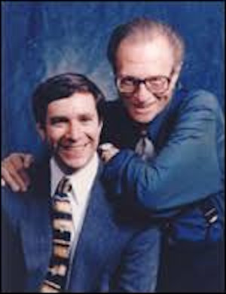
Irwin Katsof and Larry King

“Larry, we'd like to bring this group on the first-ever visit to meet with King Hussein of Jordan, in the Palace. Can you call King Hussein and make this happen?"
"Of course, Rabbi. My pleasure. Done."

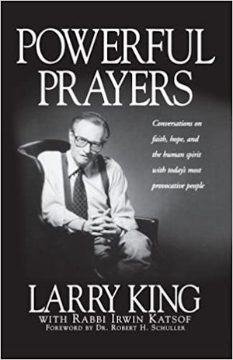

Behind the scenes, quietly and with little fanfare Larry, who I always called by his Hebrew name, Leibel Zeiger, was working for the Jewish people. He was not afraid to ask others to help and he was even eager to use his fame and name recognition to do good. There was a spark deep within him that acknowledged his Jewish roots and wanted a connection with his people.
When I reflect on all that he did to help our outreach efforts, I am in awe of the power of the "pintele Yid" -- that Jewish spark resting within us all, just waiting for the right conditions to be brought back to life. Larry was steeped in Hollywood but his Jewish soul was yearning to be ignited.
He would often tell me he was an atheist but he respected people who had faith. We discussed belief in G-d. I suggested we write a book together about famous people and their journeys to G-d and spirit. Naturally, he agreed. Out of this was born “Powerful Prayers: Conversations on faith, hope and the human spirit with today’s most provocative people."
We interviewed 100 famous people about their connection to G-d and prayer and the role G-d played in their life. It made Publisher Weekly’s ten bestselling religious books of the year. It sold over 130,000 copies.

Their Belief in G-d Touched Larry
In the book we interviewed everyone from the Dalai Lama to Karim Abdul Jabbar, from President Bush to Prime Minister Peres. Their belief and trust in G-d touched Larry deeply. It was a struggle for him to change his position on G-d, but it gave him pause and caused him to reflect about his Jewish roots.
We would study Torah together. He agreed to a meeting with Rabbi Noah Weinberg. He was
moved by Rabbi Weinberg’s big energy and promised to help him.
We talked with him about the power of the Jewish people and he talked fondly of his roots in Brooklyn and of his grandparents in Eastern Europe.

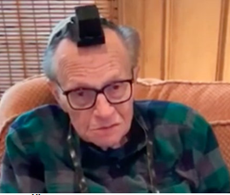
Larry King wearing tefillin

I will always remember Larry for his enormous heart and his willingness to help the Jewish people. His life touched mine and the book we wrote together reached tens of thousands and helped them examine their connection to G-d.
Behind the glitz of Hollywood, Larry was a kind, caring soul who recognized his Jewish roots and used his fame to help the Jewish people. I appreciate all he did for me. He helped make the world better and will be missed by myself and many across the globe.

Reprinted from the January 24, 2021 website of Aish.com Larry King passed away on January 23, 2021 at the age of 87 from complications of Covid-19.

Rabbi Chaim Aryeh Ginzberg Rediscovers the Beauty of Life
By Daniel Keren

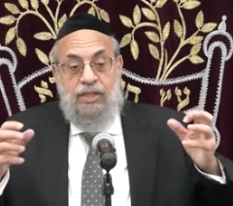

The second speaker in the January 1st Legal Holiday Hakhel Flatbush Yarchei Kallah Event was Rabbi Chaim Aryeh Zev Ginzberg, morah d’asra of the Chofetz Chaim Torah Center in Cedarhurst and internationally renowned Maggid Shiur and educator. He addressed the topic of “After Techias Hameisim Then What…Challenges of Life After (Near) Death” based on his own experiences of miraculously surviving a near fatal corona virus infection last year.
Rabbi Ginzberg began his dramatic presentation by declaring “I am not the same person who was [a featured speaker] in Hakhel events in past years. Now I only talk about the significance of life. I want to speak about what it means to wake up in the morning.”

No Rational Explanation
For the Rabbi’s Survival
Last year when the Covid-19 pandemic broke out, Rabbi Ginzberg became very ill and was in a hospital in Nassau County. This past year before Rosh Hashnah [after he had recovered and been released from the hospital], he asked one of the doctors [a frum gentleman] who had treated him if there was any explanation for his survival.
The doctor answered: “Rabbi in the Intensive Care Unit, there were 12 other people and you were one of the three worst cases. Yet, you were the only one who survived and left the ICU.” In other words, his survival had no natural rational explanation.
He told the Hakhel audience that just before Pesach, his condition had so deteriorated that his wife got a phone call from the hospital warning her that she had just a few hours to come and say goodbye to her husband as the hospital planned to pull out all of the plugs as they desperately needed the machine [a ventilator] to use for someone else who had more of a chance to survive.

The Classic Question of Why
Iyuv (Job) Was Punished
Rabbi Ginzberg brought up the classic question of why Iyuv (Job) was punished so harshly with yissurim (bodily pains). In the Talmud it is recorded that when Paroh thought of drowning the male Jewish babies, he first asked for the opinions of the three great non-Jewish personalities of his generation – Bilaam, Yisro and Iyuv.
Bilaam urged Pharaoh to kill the Jewish male babies. Yisro demonstrated his disapproval of the plan and had to flee for his life. Iyuv seeing Paroh’s reaction to Yisro, merely remained silently.
Yisro was obviously rewarded by Hashem in that he became the father-in-law of Moshe and gave him valuable advice on how to judge the Jewish people, meriting a parsha in the Torah that was named in his honor.
Bilaam was punished by later being quickly killed by the Jews in the Midbar (wilderness) after giving Balak evil advice on how to harm the Jews by enticing the men to acts of immorality. That seems like an easy punishment when compared to the indescribable yissurim that Iyuv suffered for seemingly just remaining silent to Paroh’s question.

The Precious Opportunity that
Only Life Can Afford One
The answer, Rabbi Ginzberg, explained is that even though Iyuv was in such terrible and unremitting pain, he was still nevertheless still alive and there is still a great benefit and brocha (blessing) for the precious opportunities that only life can allow a person, especially with regards to serving Hashem.
Rabbi Ginzberg recalled the more recent story of the late Rabbi Shimon Schwab who towards the end of his life lost the use of his legs and was confined to a wheelchair. One of his grandsons who hadn’t seen in him in three years was shocked and greatly saddened to see his zeidie so constricted. He asked his grandfather how he was able to be so cheerful and accept this new limitation in his life.
Rabbi Schwab explained by way of a moshul (parable.) Imagine that a rich man offers you an interest free loan of a million dollars but with a condition that you repay it when he asks. Many, many years pass and the rich man never calls in his loan. Than one year he calls and say ask if you remember the million dollar loan he gave you. You say yes and ask if he wants the million dollars back. He says, that he just wants you to give him back a thousand dollars and you can keep the rest of loan forever.
Rabbi Schwab explained that everything in life is like an interest free loan from Hashem and if one is blessed with a beautiful family, including children and grandchildren who follow in the derech Hashem and one has been able to lead a productive life, then if towards the end of one’s life, a person loses the ability to walk, it is like the rich man forgiving most of his loan to a man.

The Story of Two Jewish Brothers –
Nathan & Isidore Straus

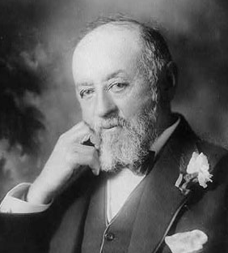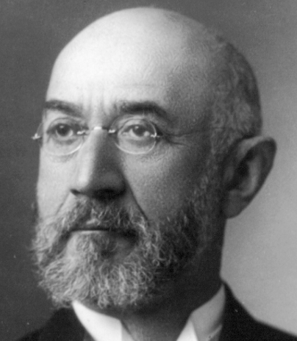
Nathan Straus and Isidore Straus

Rabbi Ginzberg recalled recently reading a magazine article about the Israeli city of Netanya. The story goes back almost 108 years ago to when two Jewish brothers – Nathan and Isidore Straus (owners of Macy’s Department Store and Abraham & Straus Department Store) decided to take a six-month vacation with their wives touring through Europe.
During their trip to all of the classical sites of Europe, someone asked them if they intended to visit Palestine where many Jews were beginning to create new communities. It wasn’t on their itinerary, but both brothers thought it would be nice to spend a week in the Holy Land that was rich with Jewish history.
During that week, the brothers and their wives travelled to different communities and generously donated to institutions that would help their Jewish brethren. However at the end of the week, Isidore was anxious to resume his European tour. However Nathan wanted to see more of the Jewish settlements and help them with philanthropic donations.
Because of that he missed joining his brother and sister-in-law on travelling on a special ship making her maiden journey towards America. That ship was the RMS Titanic. One of Nathan’s donations while in Palestine was to helping a fledgling Jewish settlement being created on the Mediterranean Sea. And they honored his donation by naming their community in his honor – Natanya.

The Importance of Just One Small Decision
Rabbi Ginzberg noted that was just one small decision. Should we go or should we stay for a few more weeks? The result was that one brother perished and one survived. Nathan who lived another 19 years spent the rest of his life devoting himself to giving philanthropic donations to Jewish causes in behalf of the memory of his brother and sister-in-law.
Regarding his own personal saga of survival, Rabbi Ginzberg recalled that after returning home after spending six and a half weeks in the hospital, including three weeks on the ventilator, he heard the sound of rain drops hitting the windows of his bedroom. At that very moment he felt so overwhelmed with the sensation that Hashem was lovingly talking to him.
Rabbi Ginzberg recalled talking to Rabbi [Elazar Menachem Man] Shach towards the end of his long life had difficulty in hearing and seeing and no longer had the sense of taste when eating his food. But despite those physical limitations, the world renowned Ponevezh Rosh Hayeshiva declared that his sense of emunah (belief) in Hashem had never been greater.
To go through life, Rabbi Ginzberg said, a person’s mission is to despite all the difficulties grasp every opportunity to come closer and better serve Hakodesh Baruch Hu.

Reprinted from the January 3, 2021 edition of The Jewish Connection

Story #1207
The Irreligious Shabbat Observing General
From the Desk of Yerachmiel Tilles

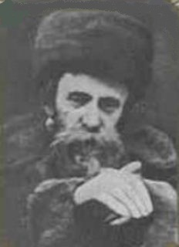
Rav Aharon of Belz, zt”l

An elderly person asked Rabbi Aharon of Belz whether he was permitted to daven Shemonah Esrei while sitting down.
Rebbe Ahron replied, “According to Jewish Law, you may sit. However, my father, the Rebbe, (Rabbi Yissachar-Dov of Belz) would say, ‘A person shouldn’t give in. Don’t turn yourself into an invalid, into someone who needs to find shortcuts. One should always be prepared to overcome all challenges.”
* * *
An elderly Jew used to pass by the cheder (school for children) of the Belzer chasidim in Tel Aviv in his wheelchair almost every day, because he enjoyed speaking with the children. He wasn’t religious but was brought up in a religious home. The children spoke to him about faith in G-D, and encouraged him to keep Shabbos and the other mitzvos.
He said, Don’t speak to me about emunah (faith), because I believe in G-D more than you do,” and he told them his story:

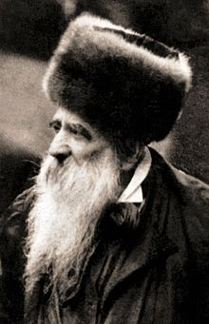
Rav Yissachar Dov Rokeach, zt”l

“When I was young, in Poland, I wanted to join the army. My father brought me to Rabbi Yissachar Dov of Belz. The Rebbe told me, “You want to join the army? OK, I will not try to stop you. But I demand from you one thing: You must always keep Shabbos.”
“There were crutches in the Rebbe’s room. The Rebbe pointed to them and said, ‘Just a few moments ago, an invalid came in wearing those crutches. I told him to leave my room without them, because he doesn’t need them anymore. But if you won’t keep Shabbos, those crutches are waiting for you!’”
“I was afraid, and therefore I always kept Shabbos, even though I wasn’t religious at all otherwise. Eventually, I made aliyah to Israel and reached a high rank in the IDF (Israel Defense Forces). In fact, I was a general in the Six Day War.
When the war ended I was invited to tour and see the new borders. The tour was long, and would be on Shabbos too. In the euphoria of the moment I didn’t think much about it and joined the tour. I was riding on a tank. I didn’t allow myself to think about Shabbos.
“On Friday night, the moment Shabbos began, the door of the tank suddenly opened and I fell out. Since then I’m on crutches. So don’t speak to me about emunah. I experienced the truth of emunah.”
The children asked him, “So if you believe, why don’t you keep all of the mitzvos? Why only Shabbos?”
The man pointed to his heart and said, “this treifa (unkosher) heart!” His impure heart didn’t permit him to act as he knew he should.
~~~~~~~~~~~~~~~~~
Source: Adapted by Yerachmiel Tilles from the Parshas Toldos 5777 email of Torah Wellsprings: Collected Thoughts from Rabbi Elimelech Biderman, as compiled by Boruch Twersky.
Rabbi Biderman’s conclusion was: This man certainly had his challenges, and we can’t judge him. But we must realize that that isn’t any valid excuse. Challenges were given to us for us to overcome them.
Connection: Weekly Reading - Not to go on Shabbat more than a kilometer in an uninhabited area. [This is the first specific mention of Shabbat observance in the Torah. -- see Beshalach Ex. 16:25-30]
Biographical Note : Rebbe Yissachar-Dov (Rokeach) of Belz [5612 - 22 Cheshvan 5687 (1851 - October 1926)] was the third Rebbe of the Belz chasidic dynasty, from 1894 until 1926. He was renowned as a miracle worker, and attracted thousands of devoted followers. A prominent leader of Galician Jewry, he strongly opposed the fledgling Zionist movement, which he saw as a threat to Jewish continuity. (based on Wiki)

Reprinted from the Parshat Beshallach 5781 email of KabbalaOnline.org, a project of Ascent of Safad.

Amar’e Stoudemire, Now a Brooklyn Nets Coach,
Doesn’t Work on Shabbat
By Gabe Friedman

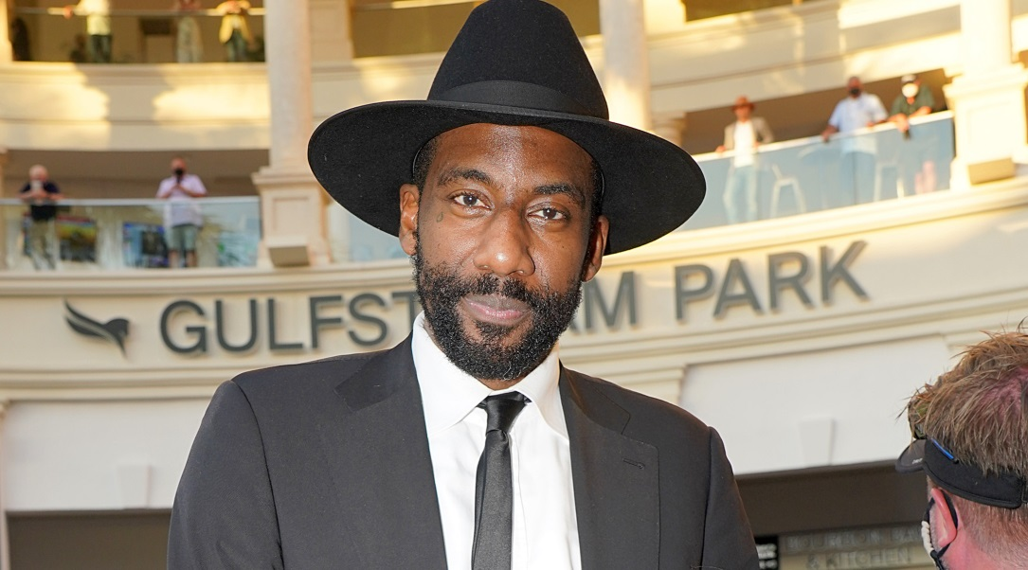
Amar'e Stoudemire attends the Pegasus World Cup Championship horse racing event in Hallandale Beach, Fla., Jan. 23, 2021. (Alexander Tamargo/Getty Images for The Stronach Group)

(JTA) — Amar’e Stoudemire, the former NBA star-turned-Orthodox-convert to Judaism and Israeli team owner, is still settling into his new job as an assistant player development coach for the Brooklyn Nets. One fact that is helping him get comfortable: The team is not forcing him to work on Shabbat, which he observes.
Writing about Stoudemire and his new gig in December, Marc Stein of The New York Times reported that the team was still working through how to deal with the star’s request about the Jewish Sabbath. Stein wrote that Stoudemire was having a little trouble adjusting to being called a “coach” while not being officially retired as a player. Last year Stoudemire played for Maccabi Tel Aviv and helped the Israeli club win a championship in the country’s top league.
On Monday, Stein tweeted that the team has agreed to Stoudemire’s ask.
“[T]he Nets are granting Shabbat off to Stoudemire every week — Friday sundown through Saturday sundown,” Stein wrote.
The development is symbolic of Stoudemire’s stricter adherence to Jewish law over time. He completed a formal Orthodox conversion in August.
Stoudemire, once an All-Star for the Phoenix Suns (where he played alongside current Nets head coach Steve Nash), detailed his Jewish journey in a late December talk with the UJA-Federation of New York.

Reprinted from the January 26, 2021 dispatch of the JTA (Jewish Telegraphic Agency)

How Much Do You Trust?
By Rabbi Dovid Goldwasser

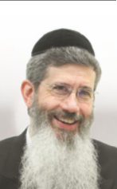

“I shall rain down for you food from heaven; let the people go out and pick each day’s portion on its day…” (Shemos 16:4).
The Talmud (Yoma 76a) relates that the students of R’ Shimon bar Yochai asked: Why didn’t the mahn just fall once a year? R’ Shimon bar Yochai answered with a parable: A king with an only son would give him an allowance for which the son would visit his father once a year. The king decided, though, that he wanted to see his son more often, so he only granted him enough provisions for one day; that way, his son had to visit him every day.

By daily receiving enough mahn for only one day, the Jewish nation had to constantly direct their hearts to Hashem for His sustenance in the midst of the desolate desert.
It is told that a rich man came one Motzei Shabbos to R’ Yaakov Chizkiyah Greenwald, the Puppa Rebbe, and gave him a large sum of money. The next Motzei Shabbos he came again and again gave the Rebbe a large sum of money. When the wealthy man returned the third Motzei Shabbos with a monetary gift, the Admur refused it, saying, “You have already given me enough.”
The wealthy man said, “I have a lot of money and my gifts to you have brought me much beracha. Why can’t I give you more money?”
“If I know I can get money at any time,” responded the tzaddik, “it will wear away my bitachon, my trust and faith in Hashem.”
It’s interesting to note that when Lavan told Yaakov (Bereishis 30:28), “Specify your wage to me and I will give it,” Yaakov responded, “Don’t give me anything.” The Radak comments that Yaakov wanted his sustenance to come from the goodness of Hashem, as we say in Birchas HaMazon, “Make us not needful of the gifts of human hands…but only of Your Hand that is full, open, holy and generous….”
R’ Avraham Yehoshua Heschel of Apt, the Ohel Yisroel, would often tell of an innkeeper who became a miracle worker. It was said that whatever beracha the innkeeper gave would eventually be realized. His fame spread far and wide and reached the ears of the Ohev Yisroel.

The Tzadik was Troubled
The Ohev Yisroel was troubled, fearing that the man was perhaps resorting to black magic or secrets of Kabbalah to perform miracles and decided to travel to the city where the innkeeper lived to observe him. He stayed there for a while to monitor the innkeeper’s ways and was happy to note that nothing seemed amiss. The innkeeper seemed to be a typical Torah-observant individual.
Finally, the Apter approached him and revealed who he was. He then explained that he wanted to learn the innkeeper’s secret to having his berachos fulfilled.
The innkeeper replied humbly, “I’ll be honest with you. I have placed all my faith in Hashem. There was a time when my business failed, and we were destitute. There was no money at all, and the family was going hungry. My wife was distraught and advised me to travel to a different city and find a partner who would invest in my business. I was reluctant to do that, but my wife insisted.

Made a Partnership Deal with Hashem
“As I was walking through the forest on the outskirts of the city, I had a thought. I called out to Hashem: Master of the world, in the Grace After Meals we ask, ‘Make us not needful of the gifts of human hands nor of their loans.’ I do not want to be partners with a human being. I want You, Hashem, as a partner, and I promise that we will be equal partners. Everything will be divided 50-50.’
“I then returned home and intensified my faith and trust in Hashem. Every dollar of profit was divided, with half going to the poor people who desperately needed tzedakah. Ever since that day,” concluded the innkeeper, “my business has flourished. I cannot adequately thank my ‘partner’ for all the blessing I have in life.”
Upon hearing these words, the Ohev Yisroel blessed the innkeeper, “May there be many like you in the nation of Israel.”

Reprinted from the January 28, 2021 website of The Jewish Press.

19th Century Pair
Of Passover Plates

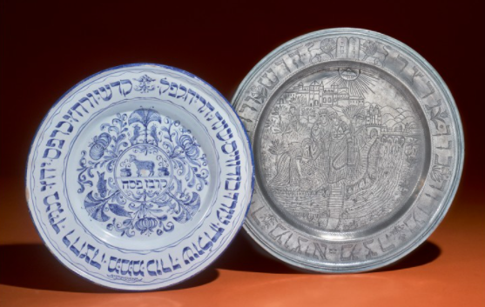

A continental Blue and White Delftware Passover Plate and Alsatian Pewter Passover Plates dated 1858 and circa 1802 that sold in the Nov. 20, 2019 Sotheby’s auction of the Arthur and Gitel Marx Collection for $5,000.
He is Israel’s ‘Prince of Torah.’ But to Some, He
Is the King of Covid
By Patrick Kingsley

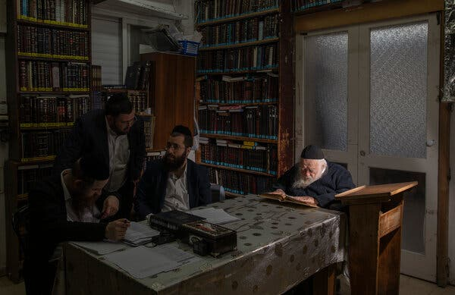
Rabbi Chaim Kanievsky at home, where his pronouncements have made him one of the most controversial figures in Israel today. Photo Credit...Dan Balilty for The New York Times

Rabbi Chaim Kanievsky is the spiritual authority for hundreds of thousands of ultra-Orthodox Jews. But his pronouncements on the virus have made him a villain to many.
BNEI BRAK, Israel — Rabbi Chaim Kanievsky, 93, can’t use a phone. He rarely leaves his house. His family says he has never successfully made a cup of tea. His closest aides think he doesn’t know the name of Israel’s prime minister. He studies the Torah for, give or take, 17 hours a day.
Yet despite his seeming detachment from worldly life, Rabbi Kanievsky has become one of the most consequential and controversial people in Israel today.
The spiritual leader of hundreds of thousands of ultra-Orthodox Jews, Rabbi Kanievsky has landed at the center of tensions over the coronavirus between the Israeli mainstream and its growing ultra-Orthodox minority.

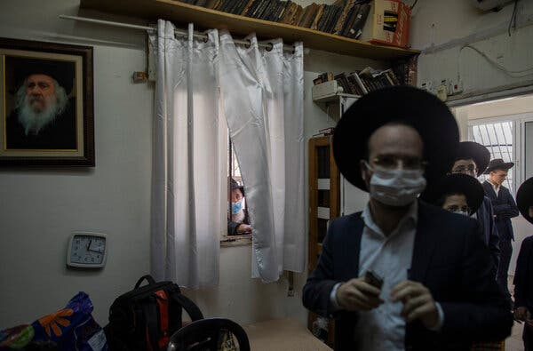
Rabbi Kanievsky’s followers line up at his home to receive a blessing or to ask questions, which he answers for a few hours a day.Credit...Dan Balilty for The New York Times

Throughout the pandemic, the authorities have clashed with the ultra-Orthodox over their resistance to antivirus protocols, particularly their early refusal to close schools or limit crowds at religious events. Similar conflicts have played out in the New York area.
Rabbi Kanievsky, issuing pronouncements from a book-filled study in his cramped apartment in an ultra-Orthodox suburb of Tel Aviv, has often been at the fore of that resistance. Twice, during the first and second waves of the pandemic in Israel, he rejected state-imposed antivirus protocols and would not order his followers to close their yeshivas, independent religious schools where students gather in close quarters to study Jewish Scripture.
“G-d forbid!” he exclaimed. If anything, he said, the pandemic made prayer and study even more essential.
Both times he eventually relented, and it is unlikely that he played as big a role in spreading the virus as he was accused of, but the damage was done.

Rabbi Kanievsky’s house in the ultra-Orthodox enclave of Bnei Brak, outside Tel Aviv. Credit...Dan Balilty for The New York Times

Many public health experts say that the ultra-Orthodox — who account for about 12 percent of the population but 28 percent of the coronavirus infections, according to Israeli government statistics — have undermined the national effort against the coronavirus.
The reaction has been fierce, much of it centered on Rabbi Kanievsky.
The rabbi “must be arrested for spreading a disease,” blared a column last week in Haaretz, a left-wing newspaper. “This rabbi dictates the scandalous conduct in the ultra-Orthodox sector,” said an article in Yedioth Ahronoth, a centrist news outlet.
The backlash exaggerates both the rabbi’s role and that of the ultra-Orthodox in general. Ultra-Orthodox society is not monolithic, and other prominent leaders were far quicker to comply with antivirus regulations. Ultra-Orthodox leaders say the majority of their followers have obeyed the rules although their typically large families, living in tight quarters under what is now the third national lockdown, have inevitably contributed to the spread of the contagion.
Rabbi Kanievsky’s position has also been more nuanced than sometimes portrayed.
Image
But he has contributed to one of the biggest-ever showdowns between the Israeli mainstream and the ultra-Orthodox, also known as Haredim.

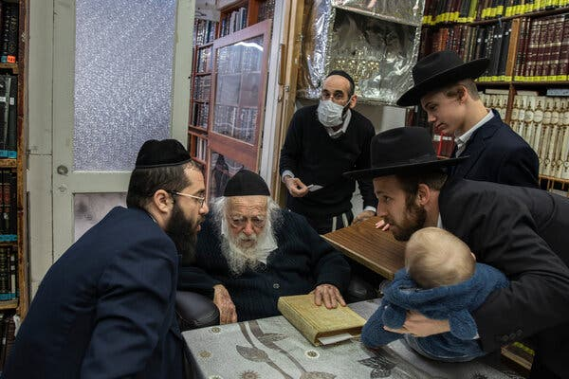
A family asking Rabbi Kanievsky for a blessing. The request goes through the rabbi’s grandson, Yakov, left, who repeats it in the rabbi’s ear. Credit...Dan Balilty for The New York Times

“I don’t remember such a case in the history of the state of Israel,” said Prof. Benjamin Brown, an expert on Haredi thought at the Hebrew University of Jerusalem. In the past, he said, ultra-Orthodox leaders have tried to avoid direct confrontation with the state.
Born in what is now Belarus in 1928, Rabbi Kanievsky immigrated to what was then Palestine before World War II. He has spent most of his subsequent waking life studying Jewish texts, gradually building a following among the so-called Lithuanian Jews, a non-Hasidic sect of ultra-Orthodox Jews with Eastern European roots who form roughly a third of the Haredim in Israel.
When the sect’s previous leader died in 2017, Rabbi Kanievsky was one of two senior rabbis who filled the vacuum, which gave him considerable authority over the sect as well as an ultra-Orthodox political party that now forms part of the government.
His pedigree adds to his prestige: His father and uncle were legendary spiritual leaders. But it is his relentless Torah study that gives the rabbi his authority — his followers believe his encyclopedic knowledge of Jewish teachings endows him with a near-mystical ability to offer religious guidance.
“They see him as a holy man,” said Eli Paley, the chairman of the Haredi Institute for Public Affairs, a Jerusalem-based research group. “They see their existence as relying on Rabbi Chaim and his Torah learning.”
On a recent afternoon in his apartment in the ultra-Orthodox enclave of Bnei Brak, Rabbi Kanievsky appeared oblivious to the controversy raging around him. He sat silently at a small wooden table covered in a silvery tablecloth, surrounded by religious books. His wrinkled and reddened hands gripped a white book of Scripture. Since rising before dawn, he had been studying the Chullin, a rabbinical text on the laws of ritual slaughter, and would continue to study late into the night.
He never gives interviews and barely registered my presence, glancing at me only briefly to offer the short blessing he gives to most visitors.
It is this devotion to religious study that made Rabbi Kanievsky — sometimes nicknamed the ‘Prince of Torah’ — so reluctant to tell his followers to close their yeshivas at the start of the pandemic. The pandemic, he believed, according to his interlocutors, made prayer and study more important, not less.
“He believes the Torah sustains the world,” said Yaakov Kanievsky, his 31-year-old grandson and the rabbi’s main mediator with the outside world. “Without Torah learning, we don’t have any reason to live. It’s written in the Bible — if you stop learning, the world will collapse.”
For a few hours each day, Rabbi Kanievsky stops studying to take questions from his followers, who either put their requests in writing or pose them in person during visiting hours. Since the rabbi is hard of hearing, the questions are relayed by his grandsons, who shout them in the rabbi’s ear and, when necessary, contextualize the questions and clarify their grandfather’s terse, mumbled answers.
A few such exchanges at the start of the pandemic quickly gained national notoriety.
“There is now a great epidemic in the world, a disease called corona and it affects many people,” one grandson shouted in the rabbi’s ear last year, following a question from a visitor, according to a video of the conversation. “He asks what they should take upon themselves so this disease does not get to them and there are no problems.”
“They should learn Talmud,” the rabbi whispered in response.
“The question is,” Yaakov asked his grandfather on a separate occasion, “if grandfather thinks that they should close the schools because of this?”
“G-d forbid!” the rabbi replied.
In an interview, Yaakov Kanievsky, better known as Yanki, said that these brief clips don’t tell the whole story. The rabbi, he said, has long complied with government policy.

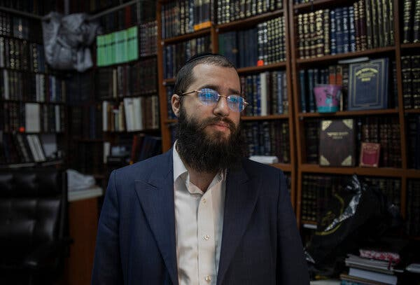
Yakov Kanievsky denies that he exercises any undue influence over his grandfather’s pronouncements.Credit...Dan Balilty for The New York Times

“There are things that get misunderstood,” Yanki said. “He takes Covid very seriously, and he takes the patients very seriously.”
Several weeks into the pandemic, the rabbi ordered his followers to obey social distancing guidelines, even equating scofflaws to murderers. In June, he said face masks were a religious obligation. In December, he gave his blessing to the vaccine, not long after recovering from the virus himself. In recent days he condemned a group of Haredi youths who clashed with police officers trying to enforce coronavirus regulations.
And he ultimately reversed himself on closing the yeshivas, which remain closed or under quarantine during the current lockdown.

“If you look at the news tonight, there will be one Haredi school open, and people will say, ‘Oh, it’s all Rabbi Kanievsky’s fault,’” Yanki said. “But it’s really not.”
Yanki’s dominant role in his grandfather’s life has led to questions about who is really in charge, and whether Rabbi Kanievsky is alert enough to judge matters of national importance. Critics say the grandson controls who can and can’t reach the grandfather — even Prime Minister Benjamin Netanyahu has not been granted the privilege of speaking with Rabbi Kanievsky directly.
It is usually Yanki who shapes the way questions are put to the rabbi, potentially influencing the way that he might answer them.
“It’s all a question of how things are presented — the man does not have the ability to figure out how things are projected to him,” said Prof. Kimmy Caplan, an expert on Haredim at Bar-Ilan University. “We’re talking about a person who has been living in Bubble Wrap for quite a few years. The man is 93 years old. I’m not taking away from his wisdom, but he is in many ways detached from reality.”
The younger Mr. Kanievsky said that his grandfather is entirely his own man, and that it would be impossible to influence him even if he tried. Everyone has the right to ask him anything — they just have to line up and wait their turn.
“I can’t tell the rabbi what to say,” said Yanki. “If he thinks I’m trying to manipulate him, I am finished.”
But without speaking to the rabbi directly, it is hard to know exactly what he thinks. As the interview with Yanki drew to close, we asked for a final audience with the rabbi.
Yanki shook his head. Rabbi Kanievsky was taking a nap.
Reporting was contributed by Myra Noveck and Irit Pazner Ga

Reprinted from the January 30, 2021 front page story in The New York Times.

